Proxy Firewall Development with Dashboard

**Architecture and Design:**

**Setup and Configuration:**

1. open project as gradle project.
2. set projcet sdk2 java1.8.
3. Execute gradle clean
4. execute gradle build.
5. Now the jar file will be generated in the build directory of the firewall project(PROJECT_DIRECTORY_PATH/build/libs/*.jar)
6. sudo java -jar PATH_TO_JAR_FILE
7. The jar file needs to be executed only on unix/linux.
8. For installation of ip tables execute the below commands:
   1. sudo apt-get update
   2. sudo apt-get install iptables
   3. sudo apt-get install net-utils

**NOTE:** IPTables data will be cleared once after booting of the system

**API DOCUMENTATION:**

* Swagger API documentation will be Available when the application starts up and run.
* Swagger Documentation PDF file can be accessed Here - [FIREWALL_API_DOC.pdf](document_reports/FIREWALL_API_DOC.pdf)
* Swagger API documentation can be accessed here – <http://localhost:7075/swagger-ui/index.html>

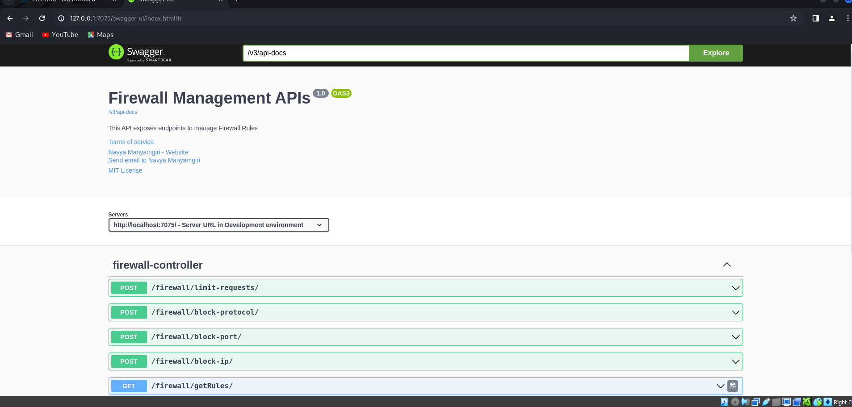

**Challenges Faced :**

The challenges faced while implementing the project are :

* Testing the Firewall System in real time – For testing in realtime it requires the Known IP systems should be setup by own and it is little bit challenging to setup the hosts. Here, the real time testing is done by setting up two linux virtual machines running under same Virtual box and a Network. (Report can be gound here - ["CSCE 5585_FIREWALL_TESTING.pdf"](document_reports/CSCE%205585_FIREWALL_TESTING.pdf)
* Understanding the concept of Iptables and maintaining the Logs generated by Iptables.